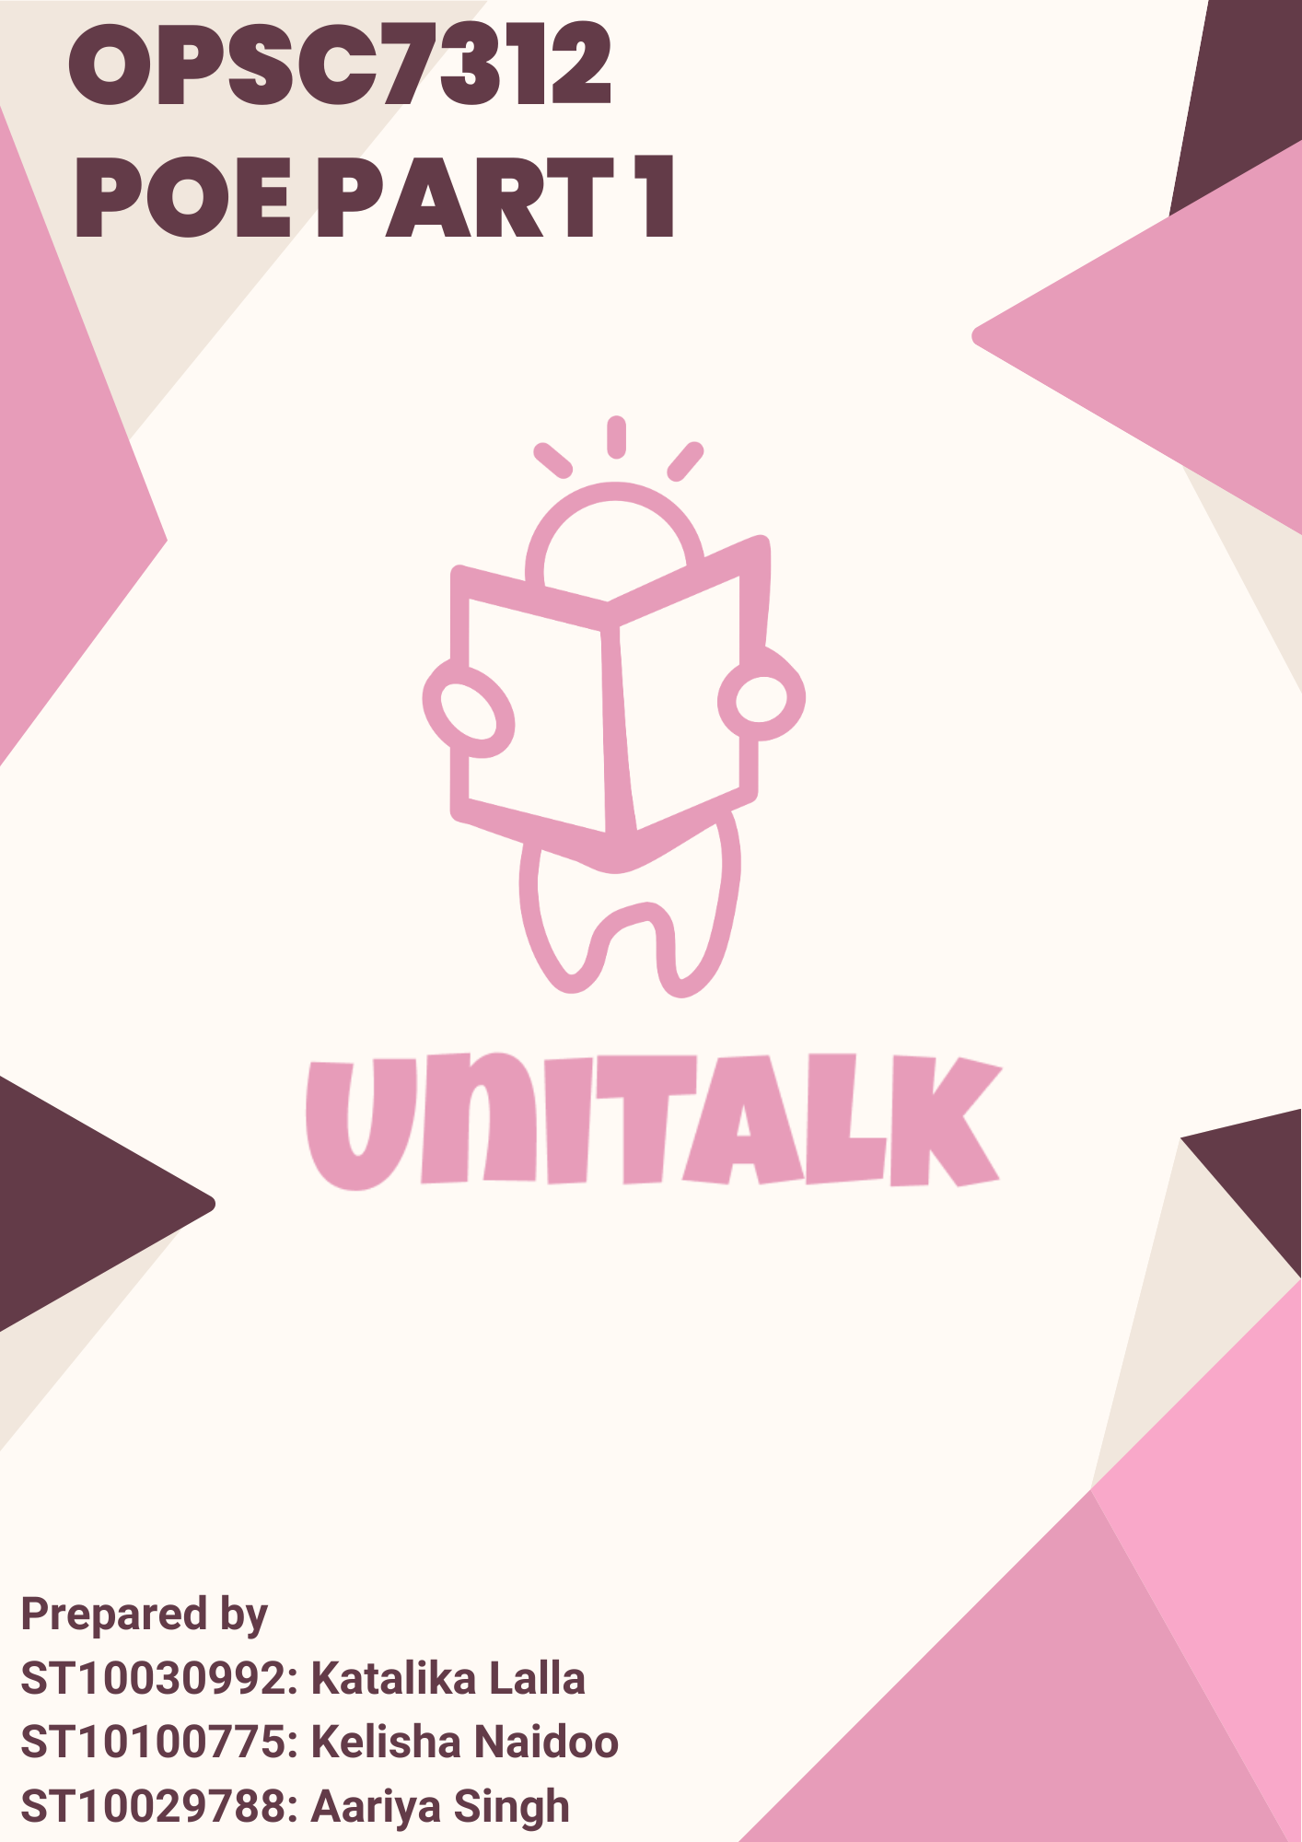

Contents

1. RESEARCH 2

1.1 Introduction 2

1.2 Application Research 4

1.2.1 Application 1: **Mobile Campus** 4

1.2.2 Application 2: **Campus 365** 8

1.2.3 Application 3: **CampusGroups** 11

1.3 Visual Comparisons 14

1.4 Best Features 16

1.4.1 Mobile Campus 16

1.4.2 Campus 365 16

1.4.3 Campus Groups 16

1.5 Conclusion 17

2. PLANNING AND DESIGN 19

2.1 Introduction 19

2.2 Application Overview 19

2.2.1 Icon Design 20

2.3 Innovative Features 21

2.4 Requirements 22

2.5 User Interface Design 24

2.6 Work Flow Diagram 55

2.7 API Design 57

2.8 ERD Diagram using UML notation 59

https://github.com/ST10029788/UniTalk/blob/7c9efe09f2321698de4ee30b79f0910823489282/ERD_UML.svg 59

2.9 Data Requirements 60

2.10 Project Plan – Gantt Chart 63

2.11 Conclusion 65

REFERENCES 66

# RESEARCH

## 1.1 Introduction

As university students, it is important to keep track of communication from professors, classmates, and campus organisations to stay informed about academic updates, group projects, and social events. This helps us ensure a well-rounded and engaging university experience (Wallace and Nixon, 2013).

Digital platforms tailored for the university experience help meet the needs of students, faculty, and college staff, providing a centralised hub for educational resources, community engagement, and administrative information.

A digital platform provides a single point of access to various academic resources, including course materials, lecture content, and administrative documents. This reduces the need for physical visits to different offices and departments.

Social features on these platforms encourage collaboration and community building, allowing members of the university to engage in discussions and share experiences.  Whilst social media tools are often regarded as easy distractions, when tailored for academic environments, it can transform into a powerful platform for organised communication, resource discovery, and meaningful engagement (Anderson, 2019).

Integrated platforms also assist in accessibility. Students have immediate access to textbooks, notes, and other educational materials, enhancing their learning experience and supporting academic success (Husnita, Rahayuni, Fusfitasari and Siswanto, 2023).

For the university itself, digital resources reduce the need for physical materials and administrative overhead, lowering costs for both the university and students (Rawashdeh, Mohammed, Arab, Alara and Al-Rawashdeh, 2021).

Digital platforms can easily adapt to growing needs and incorporate new technologies, ensuring that the university remains at the forefront of educational innovation.

Many universities have such platforms, and the research section of this report aims to analyse three of them:

* **Mobile Campus**
* **Campus 365**
* **CampusGroups**

These apps are chosen for their relevance to educational institutions and their ability to facilitate communication, resource management, and social interaction among students and faculty. Understanding their strengths, weaknesses, and implementation details will provide valuable insights to inform the development of our own college mobile application, which aims to combine the best features from each.

Analysis will assist us in gathering insights and best practices that will be used to design and develop a new application tailored to a specific university.

The report will firstly provide an overview of each app, their strengths and weaknesses, implementation insights, screenshots of the application’s interface, and a comparative analysis to identify the best features to incorporate into the new app.

From these discussions, we will outline a list of desirable features with motivations as to why they should be included in our application.

This will be followed by the Planning and Design section of the document, where we delve into the application design.

## 1.2 Application Research

### 1.2.1 Application 1: **Mobile Campus**

#### 1.2.1.1 Overview of the Application

Mobile Campus is a versatile application designed to serve as a central hub for students' academic activities and campus life. It offers a suite of features that ensure students have easy access to academic resources, keeping them informed throughout their university journey. It also allows them to stay updated on course materials, monitor grades, and keeping track of class schedules. It provides a streamlined user experience that simplifies the academic process (2U, 2021).

One of the key strengths of Mobile Campus is its integration with the institution’s online systems, making it an essential companion app that extends the functionality of the university’s online systems to mobile devices. Users can easily access and view coursework, including lecture modules for all active and past courses, enabling them to review materials at their convenience. This feature is particularly beneficial for students who need to revisit lecture content or catch up on missed classes.

In addition to academic resources, Mobile Campus provides tools for personal and social engagement. Students can record and upload videos to their profiles, allowing them to share presentations, project work, or even personal updates with their peers and faculty. This feature enhances the collaborative nature of the learning environment, encouraging students to actively participate and engage with content.

The app also supports a communication platform, where users can view and add posts on various walls, including those dedicated to courses, personal contacts, and groups. This functionality builds a sense of community within the university, allowing students to discuss course-related topics, share insights, and collaborate on group projects.

Overall, Mobile Campus is designed to be a go-to platform for students, providing them with the tools they need to manage their academic life effectively. By combining academic resources with social interaction features, the app supports a holistic university experience, helping students to stay organized, engaged, and connected to their academic and social networks.

#### 1.2.1.2 Strengths:

* User-friendly interface that is easy to navigate, making the app accessible to all users.
* Integration with institutional systems for real-time updates on grades and schedules.
* Strong focus on providing essential academic information immediately.
* Allows users to download important documents for more accessible information without an internet connection.
* Users can watch lecture content using the platform.

#### 1.2.1.3 Weaknesses:

* Limited social interaction features, reducing its potential as a comprehensive social platform.
* The app could benefit from more advanced customization options.
* Some users report occasional syncing issues with institutional databases, which can disrupt the user experience.

#### 1.2.1.4 Implementation Analysis:

* Likely developed using native mobile development (Java/Kotlin for Android and Swift for iOS) with a strong backend service for real-time data synchronisation and push notifications. The integration with institutional systems suggests the use of secure APIs and possibly middleware services for data handling.

#### 1.2.1.5 Screenshots

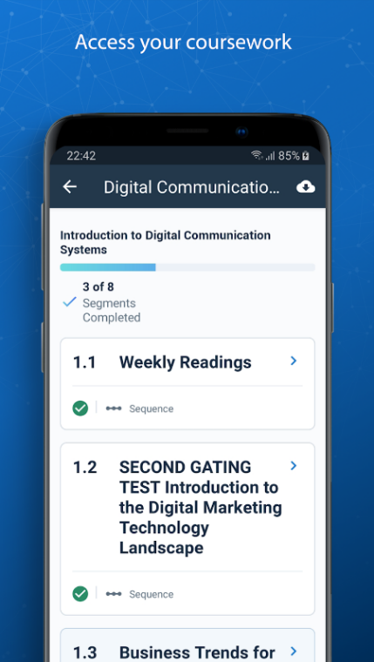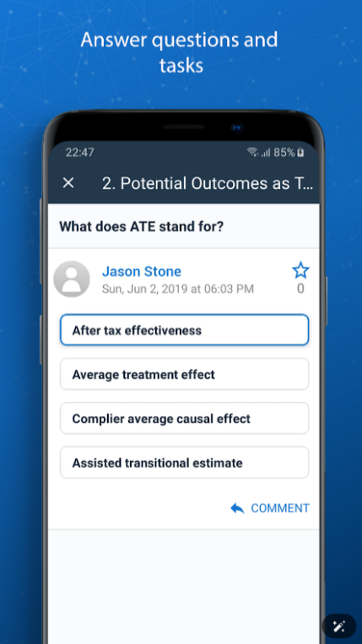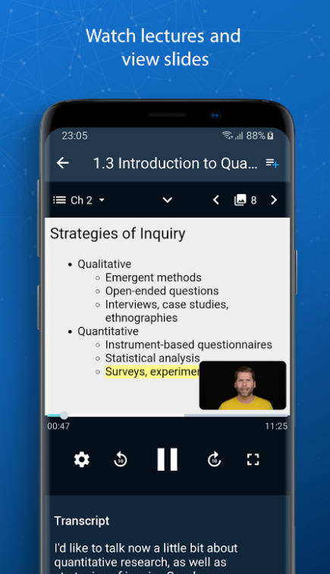

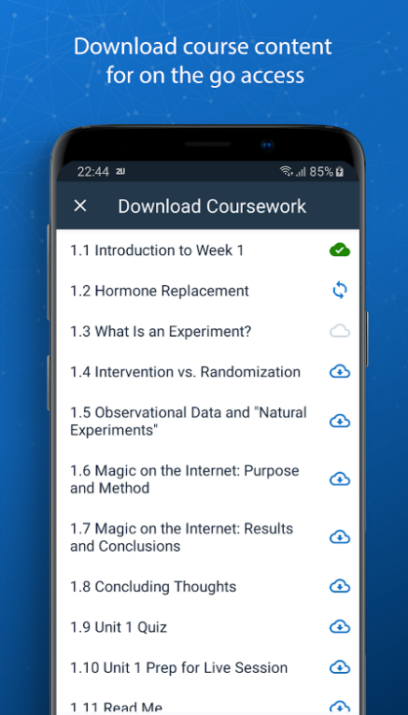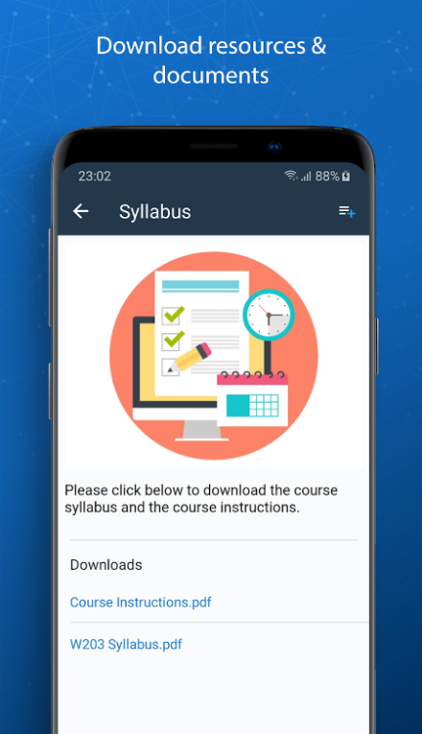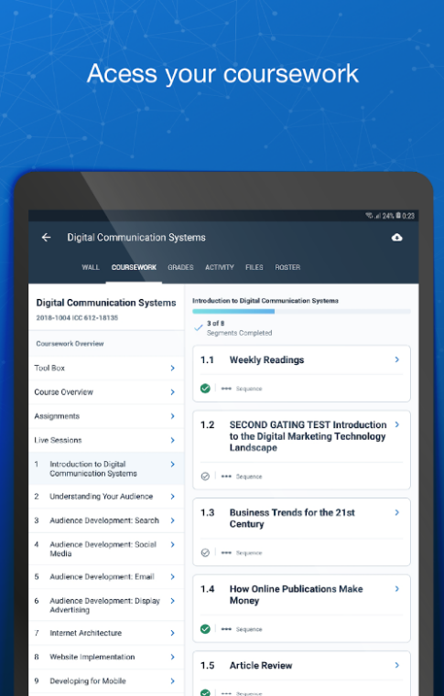

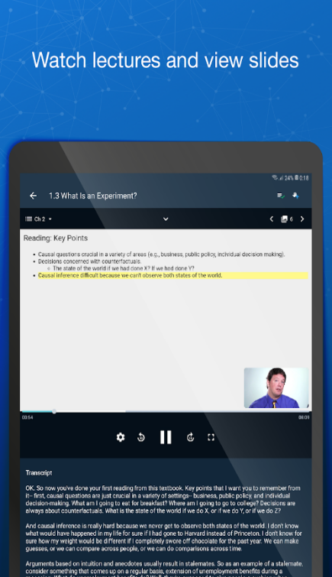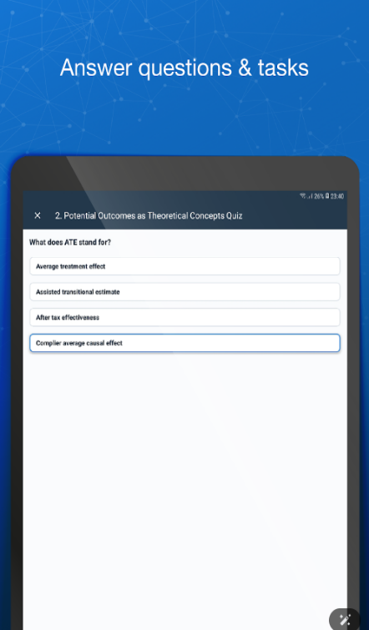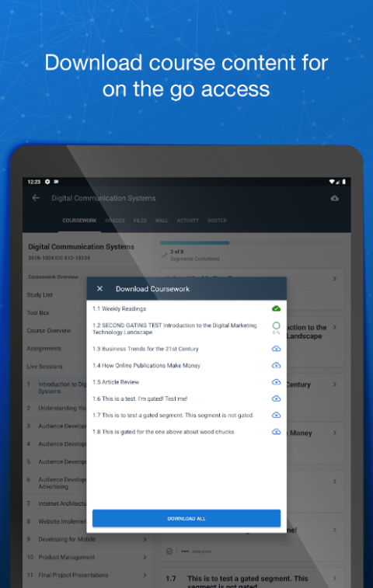

### 1.2.2 Application 2: **Campus 365**

#### 1.2.2.1 Overview of the Application

Campus 365 is another all-encompassing college management system engineered to address the many needs of educational institutions. It is designed to enhance the efficiency of both academic and non-academic tasks, thereby allowing educational institutions to focus more on delivering quality education and less on managing day-to-day administrative complexities (Campus, 2021).

At the core of Campus 365 is its ability to efficiently manage attendance, ensuring that both students and faculty can easily keep track of class participation. This feature not only automates the process of recording attendance but also provides real-time data that can be accessed by students, teachers, and administrators alike.

Fee management is another component of Campus 365, offering a streamlined process for handling various financial transactions within the institution with customizable options, Campus 365 can cater to different fee structures, payment plans, and financial aid packages, ensuring that all financial processes are handled with accuracy and efficiency.

Timetable scheduling is another valuable feature, enabling institutions to create, manage, and distribute schedules that are optimized for both students and faculty. The system can accommodate various scheduling needs, such as class rotations, faculty availability, and room assignments, while also allowing for adjustments as needed. This flexibility is aides in accommodating changes due to holidays, special events, or unforeseen circumstances, ensuring that the academic schedule remains organized and up to date.

In summary, Campus 365 is a platform that transforms how educational institutions can handle their administrative tasks. By automating and optimizing key processes such as attendance tracking, fee management, and timetable scheduling, Campus 365 not only improves operational efficiency but also enhances the educational experience for students, faculty, and administrators.

#### 1.2.2.2 Strengths:

* Extensive administrative features, making it a solution for managing the operational aspects of an educational institution, ensuring efficiency and organization.
* User-friendly interface, making it easy for users of all technical levels to navigate and utilize its features.
* Customizable modules for different institutions.
* Gamification features such as a leaderboard for progress tracking, adding an element of fun and competition to their academic journey.
* Has a chat section for communication, which promotes collaboration, quick information sharing, and a stronger sense of community within the institution.

#### 1.2.2.3 Weaknesses:

* Focuses heavily on administrative tasks, with less emphasis on student engagement, which might make the app feel more like a management tool.
* Limited integration with external services, and this restriction may reduce its overall functionality and necessitate the use of additional apps to fulfil all user needs.
* The mobile experience is sometimes less polished compared to the web version, which could impact the app's usability on mobile devices.

#### 1.2.2.4 Implementation Analysis:

* Developed using modern web technologies for the backend, with a hybrid approach for mobile apps (likely using frameworks such as React Native or Flutter). The focus on customization suggests a modular design pattern.

#### 1.2.2.5 Screenshots:

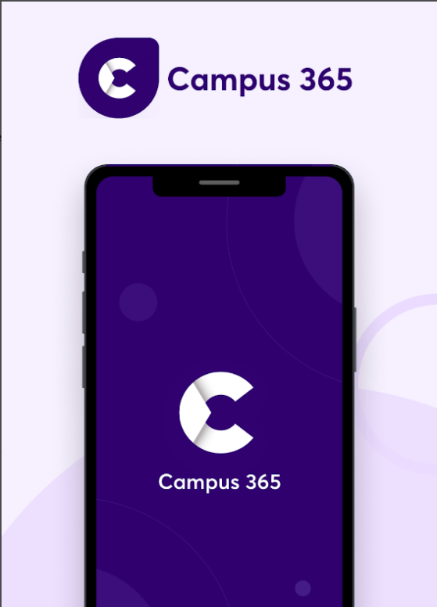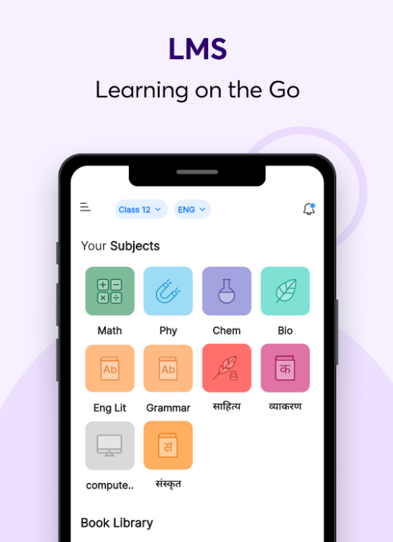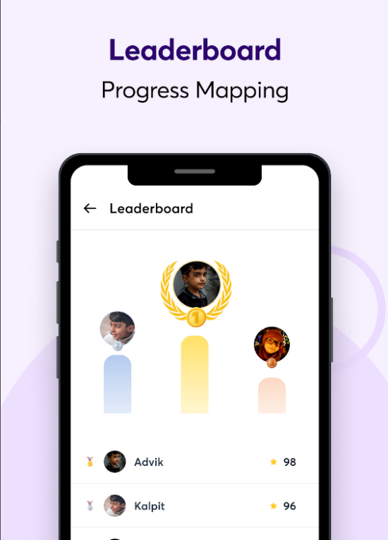

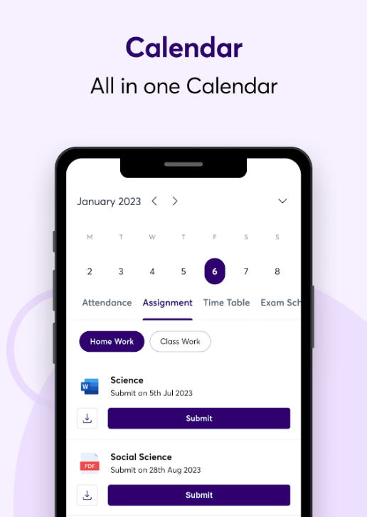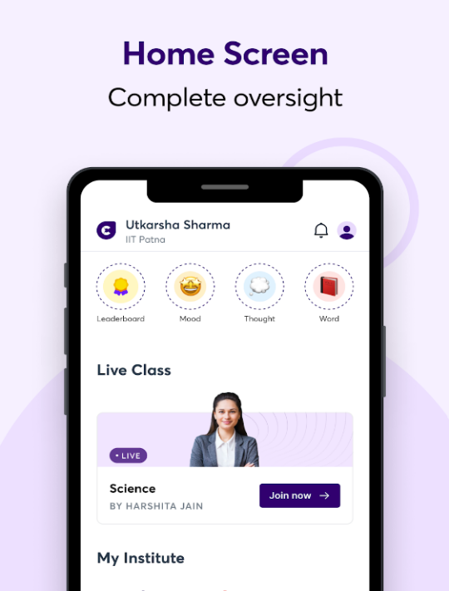

### 1.2.3 Application 3: **CampusGroups**

#### 1.2.3.1 Overview of the Application

CampusGroups is a versatile platform specifically designed to enrich the campus experience by promoting student engagement, streamlining event management, and promoting social interaction. It serves as a digital hub where students, faculty, and campus organizations can connect, collaborate, and participate in university activities. By integrating a range of features that support social and extracurricular activities, CampusGroups plays a large role in building a sense of community within the campus environment (Novalsys, 2021).

Messaging is key feature of CampusGroups, designed to facilitate communication between students, faculty, and staff. The platform supports both individual messaging and group chats, making it easy for users to connect with peers, professors, and campus leaders. This communication tool is essential for coordinating group activities, discussing course-related topics, and staying updated on campus news. By integrating messaging directly into the platform, CampusGroups ensures that all campus-related communications are centralized, accessible, and organized.

Furthermore, CampusGroups enhances social interaction by providing a space where students can share their experiences, achievements, and interests with the broader campus community. The platform supports the sharing of multimedia content, such as photos and videos, allowing students to showcase their involvement in campus activities and events. This feature not only fosters a sense of belonging but also encourages others to participate in campus life, contributing to a more engaged and active student body.

In summary, CampusGroups is a comprehensive tool enhancing campus life. By facilitating student engagement, supporting the creation and management of groups, and providing robust communication tools, CampusGroups helps build a connected, vibrant, and active campus community. Its ability to bring students together, both socially and academically, makes it an essential resource for universities aiming to create a dynamic and inclusive environment.

##### 1.2.3.2 Strengths:

* Strong focus on social interaction and student engagement, making it easier for students to connect, collaborate, and stay involved in university activities.
* Event management tools are intuitive and easy to use, enabling students and organizations to efficiently manage events, leading to higher participation rates.
* Seamless integration with campus events and activities, ensuring that students are always informed about what’s happening on campus.
* Social interaction features allow experience sharing using multimedia content, allowing students to showcase their involvement and achievements.

##### 1.2.3.3 Weaknesses:

* Limited academic features compared to other campus apps, which limits its utility as a comprehensive campus app, as it may not fully support students' academic needs like other platforms do.
* Some users report occasional bugs and performance issues, which can detract from the overall experience.
* Requires a strong internet connection for full functionality, and users in areas with poor connectivity may experience difficulties in accessing the platform’s full range of features.

##### 1.2.3.4 Implementation Analysis:

* Likely built using a mobile-first approach with APIs connecting to cloud services for data management. The emphasis on social interaction suggests real-time communication features, possibly implemented with WebSocket’s or similar technologies.

##### 1.2.3.5 Screenshots:

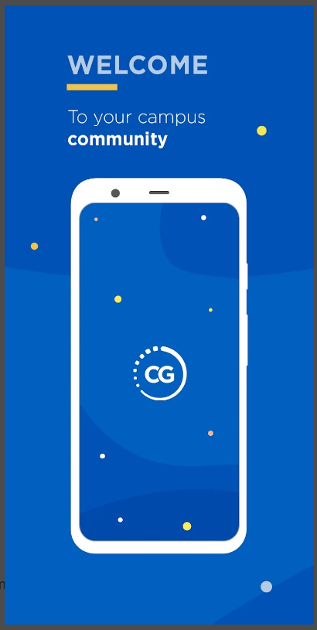

## 1.3 Visual Comparisons

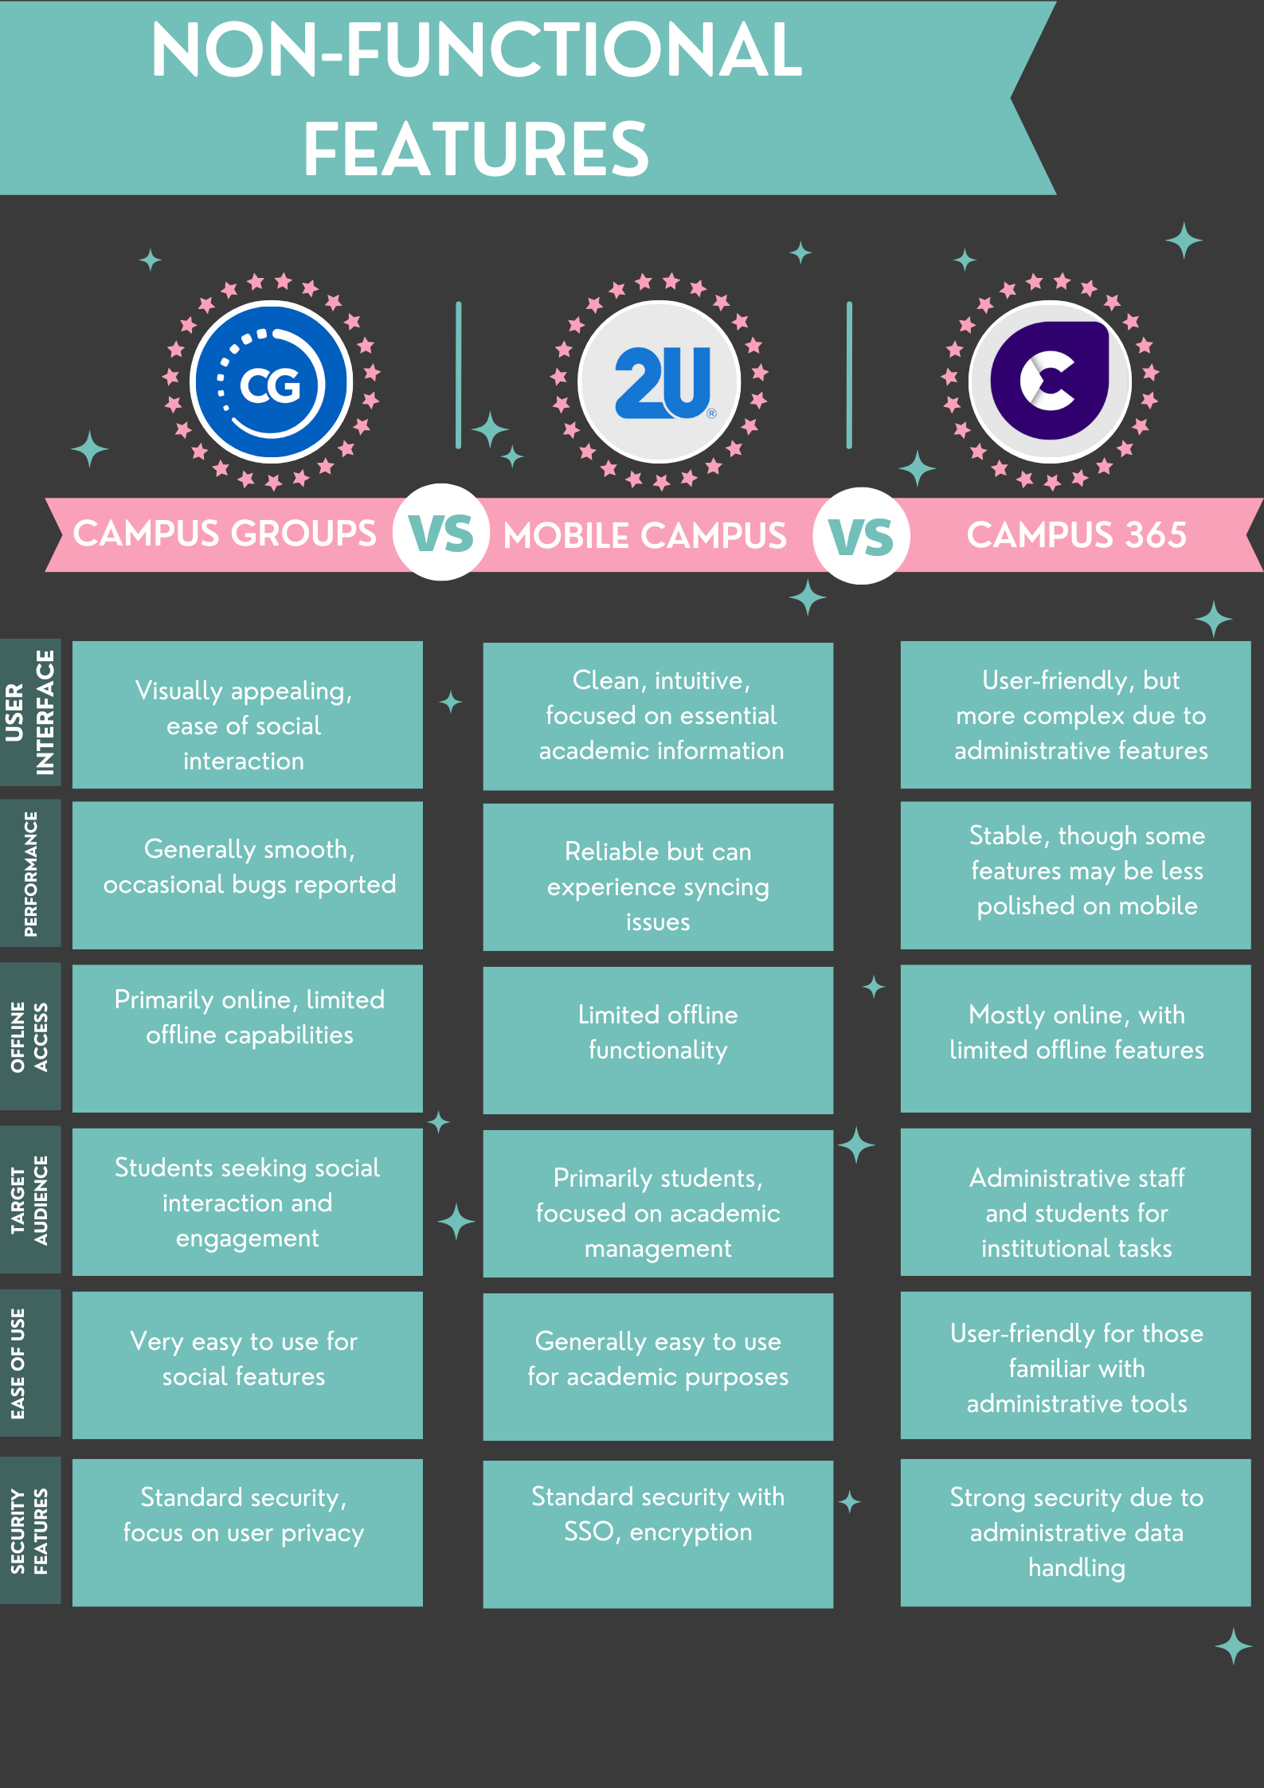

## 1.4 Best Features

### 1.4.1 Mobile Campus

* Resource Management
* Access to lecture content
* Ability to watch lecture videos
* Downloadable content
* Notice posting and viewing
* Real-time updates
* Account management

### 1.4.2 Campus 365

* Timetable posting and viewing
* Chat section for communication
* Textbook management
* Well organised, tiled dashboard for easy content access

### 1.4.3 Campus Groups

* Socials gallery
* Ability to post image and video content
* Ability to comment on other user’s posts
* Developer engagement section
* Access to the campus student portal

## 1.5 Conclusion

The development of a college mobile application tailored to the needs of students, faculty, and administrative staff is essential for fostering a cohesive and productive university environment. The analysis of existing platforms—Mobile Campus, Campus 365, and CampusGroups—provides valuable insights into the strengths and weaknesses of current digital solutions in the education sector.

Mobile Campus excels in academic management, offering real-time updates on grades, schedules, and course content, making it an indispensable tool for students who need to stay on top of their academic responsibilities. However, its limited social interaction features and occasional syncing issues highlight areas for improvement, particularly in fostering student engagement and ensuring seamless integration with institutional databases.

Campus 365 stands out with its robust administrative features, providing tools for attendance tracking, fee management, and timetable scheduling. Its customizable modules cater to different institutional needs, making it a versatile option for college management. However, its focus on administrative tasks comes at the expense of student engagement, and its mobile experience, while functional, lacks the polish and intuitiveness required for more engaging student interactions.

CampusGroups, with its strong emphasis on social interaction and event management, offers a vibrant platform for student engagement. Its intuitive event management tools and seamless integration with campus activities make it a go-to app for students looking to enhance their campus life. However, the app's limited academic features and occasional performance issues underline the need for a more balanced approach that integrates both academic and social functionalities.

By combining Mobile Campus’s academic management capabilities, Campus 365’s administrative tools, and CampusGroups’s social interaction features, a new app will create a well-rounded and user-friendly platform. This will not only streamline communication and resource management, but also create a sense of community and collaboration among students and faculty. Ultimately, this approach will ensure that the application supports a dynamic and engaging university experience, promoting academic success and personal growth.

# PLANNING AND DESIGN

## 2.1 Introduction

Navigating the complexities of college life requires effective management of academic and personal responsibilities. Many students face challenges in staying organized, accessing essential resources, and communicating efficiently with peers and faculty.

To address these challenges, we introduce **UniTalk**, a comprehensive college management application designed to streamline and enhance the student experience. Campus Connect offers a centralized platform for managing academic schedules, accessing educational resources, engaging in campus activities, and connecting with the university community. With features tailored to meet the diverse needs of students, Campus Connect aims to simplify college life and support academic and personal growth.

By incorporating the best features from Mobile Campus, Campus 365, and CampusGroups, the app aims to enhance the overall student experience.

This document outlines the planning and design phase for developing a new centralised university information application. It includes the app's overview, requirements, user interface design, API design, UML diagrams, data requirements, and project plan.

## 2.2 Application Overview

The name we have chosen is **UniTalk**. The name "UniTalk" combines "Uni" (short for university) with "Talk," suggesting a platform centered around communication and interaction within the university setting, implying a space where students, faculty, and staff can engage in conversations, share information, and connect with one another.

### 2.2.1 Icon Design

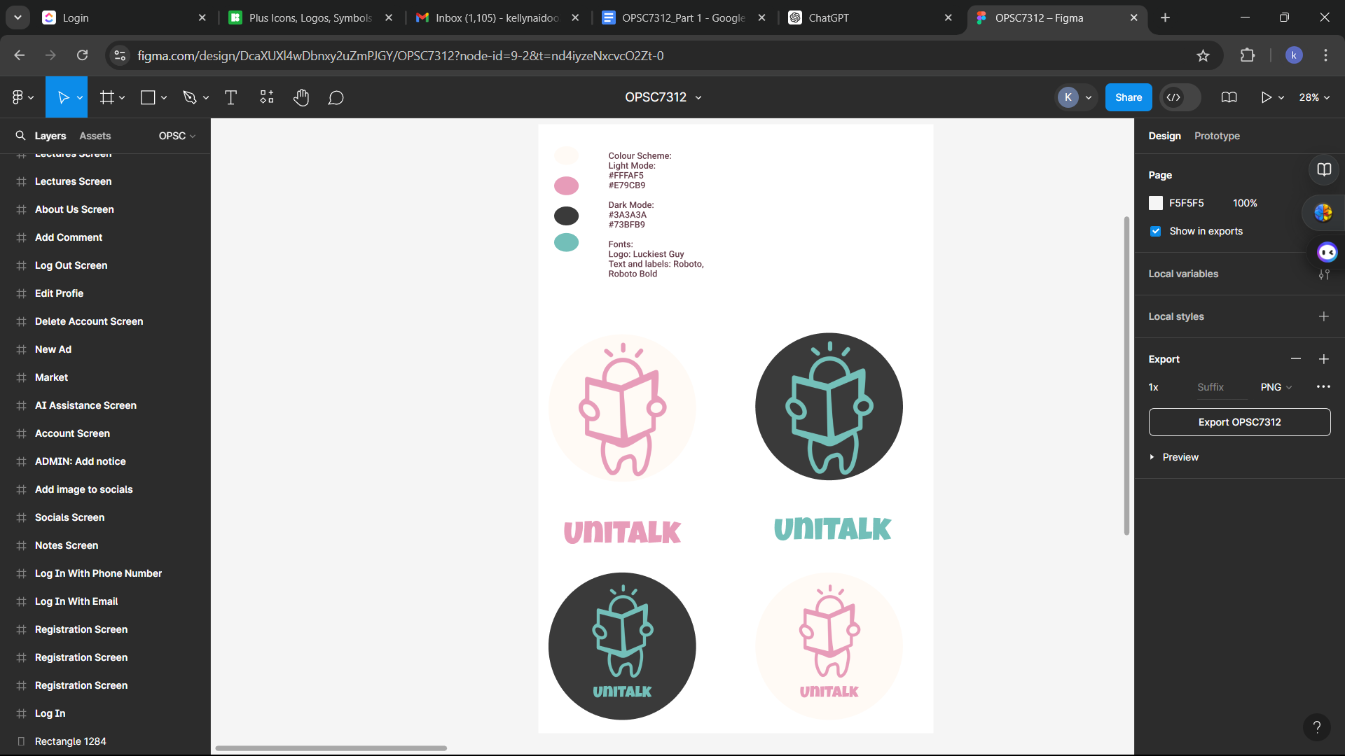

Figure 1: The UniTalk Logos proposed for Light Mode and Dark Mode. Created using Ibis Paint X.

## 2.3 Innovative Features

* **AI Assistant:** Provides academic support by answering questions and offering personalised recommendations (Srivastava, 2022).
  + **Marketplace:** A buy/sell section will enable students to list textbooks and other educational materials for sale. Other students can view these listings, communicate with the sellers, and negotiate purchases.
  + **Communication:** A dedicated chat room will be available for college members to engage in discussions related to university matters.
  + **FAQ and Help Section**: Most applications rely on a user having to research the application on their own or rely on YouTube videos or Blog posts to efficiently use time tracking applications. The help section will provide a manual for users instead, so that it is easy to access. The FAQ will also provide information that users commonly want answers to. This streamlines the process of using the app, so there is no learning curve or complexity.
  + **Easy information access through a tiled dashboard**: The dashboard screen will serve as the central hub for users, providing quick access to educational resources, important information, communication tools, marketplace listings, and more. It will offer a user-friendly interface where all the essential features of the application are organized for easy access.  
    Sections will be visually distinct and easily identifiable, with clear labels and icons, to assist in accessibility for non-technically inclined users, and neurodivergent individuals.

## 2.4 Requirements

* **Offline Mode:** Allows access to notes, schedules, and other resources without an internet connection.
* **REST API Connectivity:** Connects the app to backend services for data retrieval and updates.
* **Real-Time Notifications:** Alerts users about important events, deadlines, and messages.
* **Multi-Language Support:** Offers language options to cater to a diverse student population.
* **Log In and Registration:** The application will support multiple login methods, including email and password, with the addition of phone number and Google authentication in future updates. The user will be able to log into the app using single sign-on (SSO).
* **Forgot password**: Users have the option to reset their password if they forgot it through their registered email and will have instructions sent to their email.
  + **Authentication**: Only emails using the @[vcconnect.edu.za](http://vcconnect.edu.za) or @varsitycollege.co.za appendage can register.
    - Admin users, having the @varsitycollege.co.za appendage, have additional feature access:
* Creation, publication and deletion of notices
* Addition of student materials and information categories
* Addition of note materials and information categories
* **Biometric Authentication:** Ensures secure access to the app.
  + **Notes/Resources:** The application will provide access to educational materials, including textbooks and subject-specific notes available in PDF format. Users will have the ability to comment on, read, and download these documents.
  + **Information and student materials**: Users will be able to access critical college and subject resources, such as module outlines and module materials.
  + **Lecture Content:** A quick link to lecture content hosted on the college’s YouTube channel will be provided for easy access.
  + **Notices:** The application will feature a section for notices from the administration team. Important college announcements can be viewed and downloaded from this section.
    - Push Notifications will be given to the user when content is uploaded here.
    - Only users with the @varsitycollege.co.za appendage can upload notices.
  + **Social Gallery:** A gallery will showcase images from Varsity College’s social events and Meridian Hour events.
  + **Account Management:** Users will have the ability to manage their account information, including logging out, editing their profile, changing their password, verifying their student status via email, or deleting their account.
  + **About Us:** An "About Us" section will provide information about the developers of the application and any additional details about the app's development.
  + **Settings:** Allows users to personalise their experience. In the settings menu, users can:
    - **Notification Preferences:** Toggle push notifications on or off.
    - **Theme Selection:** Switch between dark and light themes to enhance readability and reduce eye strain.
* **Log Out Screen:** Clicking on Log Out will log the user out of their account and redirect them to the log in screen. This creates more security for the user.

## 2.5 User Interface Design

User Interface was designed based on best practice information as per the alien design, (2024) and eLearning Industry, (2020).

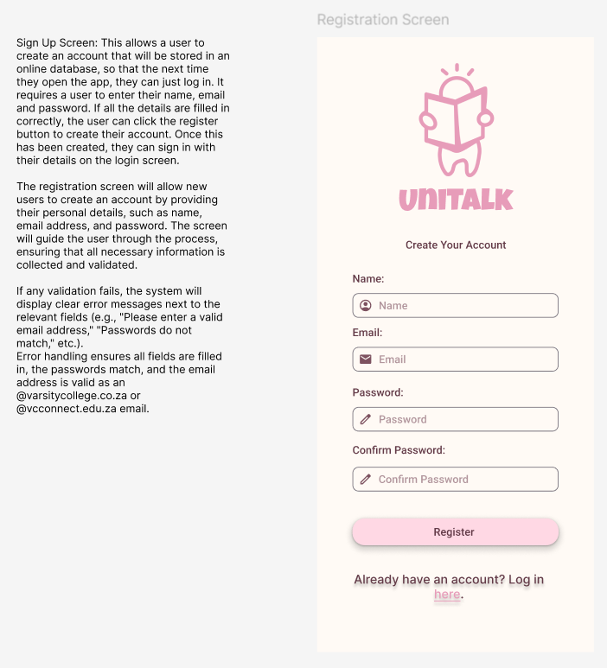

Dark Mode: Easier viewing at night to reduce eye strain. It can be activated using a toggle in the account page.

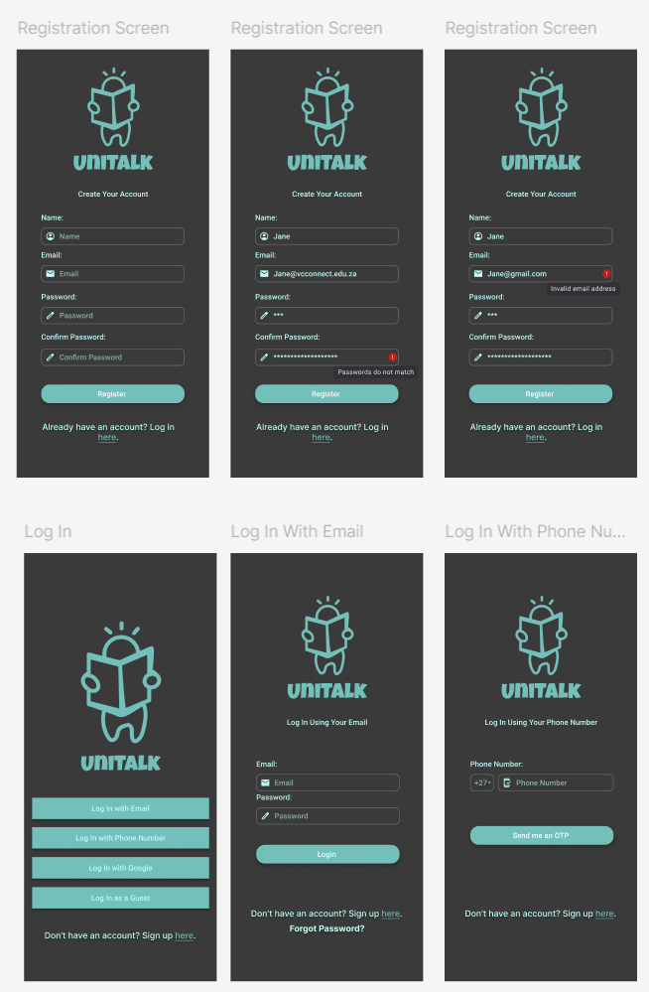

## 2.6 Workflow Diagram

The following flowchart illustrates the user journey within the UniTalk application, starting from account creation or login. New users are guided to create an account, while returning users can log in or reset their passwords. Once logged in, users access the dashboard, where they can perform various tasks like viewing notes, accessing student materials, chatting, purchasing items, viewing lectures, and managing their account details. The flowchart also includes options for users to interact with an AI chatbot, post on social media, and view information about the app. Users can log out or delete their accounts as final actions. Each decision point guides the user to the appropriate next step based on their choices.

The prototype and navigation can be accessed using the following link: <https://www.figma.com/design/DcaXUXl4wDbnxy2uZmPJGY/OPSC7312?node-id=9-2&t=ICJ6ospA8f9rdleG-1>

## 2.7 API Design

The REST API will handle user authentication and registration by interacting with the backend. It will manage login requests, password recovery, and user registration with email validation. In future updates, it will also handle phone number and Google authentication, along with guest access and biometric verification.

**Information Sent and Received**

* **Sent:**
  + **Login:** User credentials (email, password) or tokens for Google authentication.
  + **Registration:** User details (name, email, password, phone number).
  + **Password Recovery:** Email address.
* **Received:**
  + **Login:** Authentication token, user profile data.
  + **Registration:** Confirmation of registration, authentication token.
  + **Password Recovery:** Confirmation email sent status.

**Creation of Architecture**

* POST /api/login - for logging in users (user5361880, 2024).
* POST /api/register - for new user registration.
* POST /api/recover-password - for initiating password recovery.
* POST /api/google-login for Google authentication

1. Set up Retrofit
2. Create a singleton class to manage theRetrofit instance (Github.io, 2024).
3. Define an interface with the endpoints for login, registration, and Google authentication (Stackoverflow.blog, 2021).
4. Create Data Classes for API Requests and Responses, including:
   1. LoginRequest
   2. RegisterRequest
   3. GoogleLoginRequest
   4. LoginResponse andRegisterResponse (Kaushal Vasava, 2023)
5. Implement the Login with Retrofit
6. Implement the Google Login
7. Implement the Registration with Retrofit (Backendless.com, 2022).
8. Handle Token Storage
9. Test

**Hosting**

It will be hosted using Firebase Hosting.

## 2.8 ERD Diagram using UML notation

## <https://github.com/ST10029788/UniTalk/blob/7c9efe09f2321698de4ee30b79f0910823489282/ERD_UML.svg>

## 2.9 Data Requirements

1. Sign-up Screen

|  |  |
| --- | --- |
| **User Information:** | **Verification Information:** |
| * Full Name * Email Address * Password (hashed and salted) * Profile Picture (optional) * Phone Number (optional) | * Email Verification Status * Date of Account Creation |

1. Login Screen

|  |
| --- |
| **Authentication Data:** |
| * Email Address or Username * Password (hashed) * Google account data for Google Sign On * Two-Factor Authentication Data for Google Sign On |

1. Student Materials

|  |
| --- |
| Resource Data: |
| * Module Outlines * Subject Materials (Documents) |

1. Notes

|  |  |
| --- | --- |
| Educational Content: | User Interaction Data: |
| * Textbooks (PDF Format) * Subject Notes * User Uploaded Notes | * Bookmarked Notes * Last Accessed Notes |

1. Lecture Content

|  |
| --- |
| Video Data: |
| * Links to Lecture Videos (YouTube) |

1. Socials Screen

|  |
| --- |
| Social Media Data: |
| * User-Generated Content * Comments |

1. Market Screen

|  |
| --- |
| Marketplace Data: |
| * Item Listings * (Title, Description, Price, Seller) |

1. Notices Screen

|  |  |
| --- | --- |
| Announcement Data: | Read/Unread Status: |
| * Notice Title and Content * Posting Date | * Notification Settings for New Notices |

1. Chat Room

|  |  |
| --- | --- |
| Communication Data: | Group Data: |
| * Chat Messages * Sender Information * Recipient Information * Time Stamps | * Group Members Information * Group Chat History |

1. AI Assistance

|  |  |
| --- | --- |
| User Query Data: | AI Learning Data: |
| * Questions Asked * Responses Provided | * Frequently Asked Questions |

1. Settings Page

|  |
| --- |
| User Preferences: |
| * Language Settings * Notification Preferences * Theme/Colour Preferences |

1. Change/Forgot Password

|  |
| --- |
| Security Data: |
| * Current Password (verification) * New Password (hashed and salted) * Password Reset Tokens |

1. About Us

|  |
| --- |
| Static Content: |
| * Developer Information * App Version History * Legal Information (Privacy Policy, Terms of Service) |

1. Log Out Screen

|  |
| --- |
| Session Data: |
| * Session Termination Time * User ID |

17. Account Screen

|  |
| --- |
| Profile Data: |
| * Editable Fields (Name, Email, Profile Picture, etc.) * Verification Status |

## 2.10 Project Plan – Gantt Chart

Link to ClickUp: <https://app.clickup.com/9015511829/v/g/8cnvjrn-155>

Screenshots:

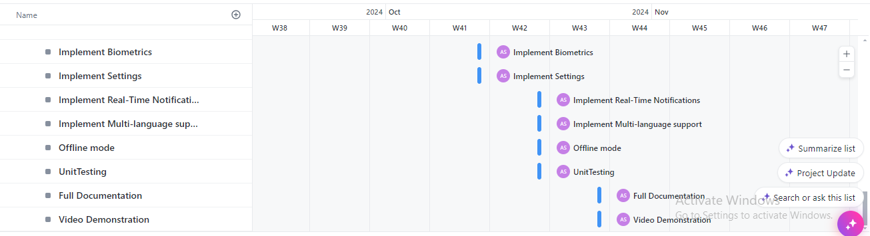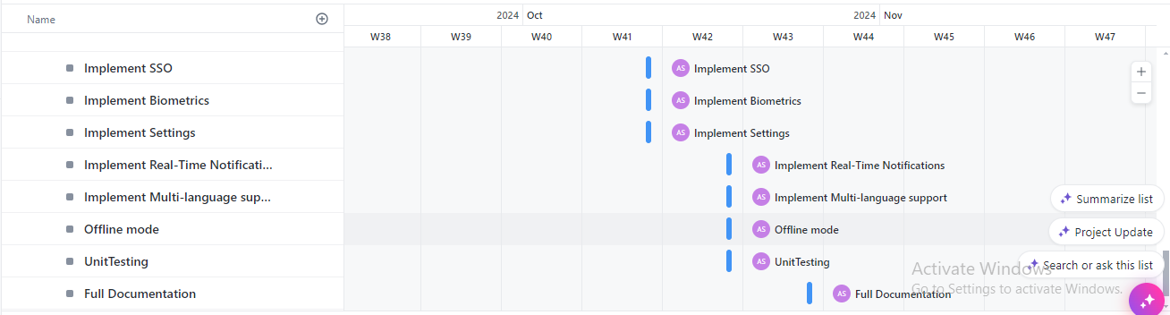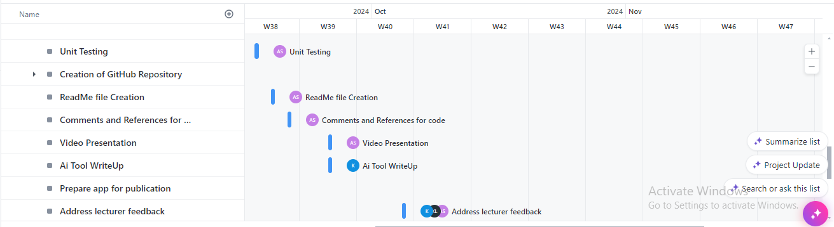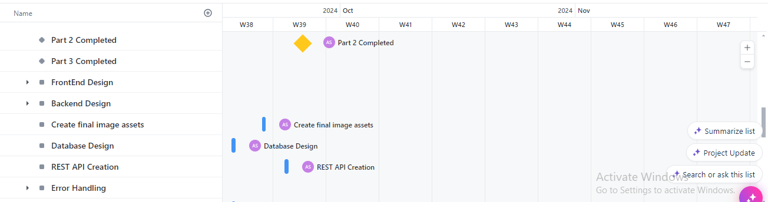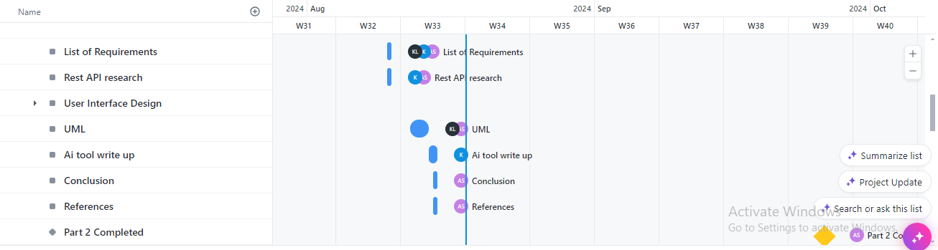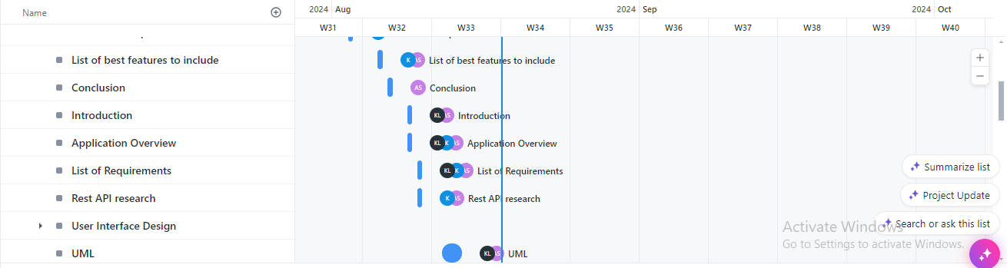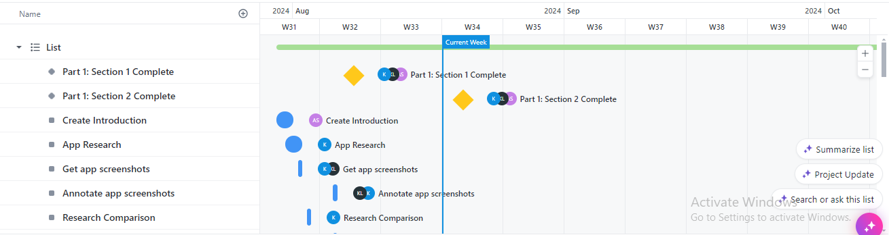

## 2.11 Conclusion

The planning and design of the UniTalk application demonstrate a complete approach to addressing the complexities of student life in a university setting. The application is crafted to provide a centralized platform that integrates essential academic tools, communication channels, and personalized services, ensuring that students can manage their academic and personal responsibilities effectively.

With features like an AI Assistant, a Marketplace, and a streamlined dashboard, UniTalk is designed to meet the diverse needs of its users. The careful consideration of user interface design, API connectivity, data management, and security protocols ensures that the application is not only functional but also user-friendly and secure.

The implementation of offline access, multi-language support, and real-time notifications further enhances the app's usability. The use of industry-standard tools like Retrofit and Firebase for backend integration and hosting increases the project's reliability and scalability.

The UniTalk application can significantly enhance the student experience, promoting better organization, communication, and access to resources within the university community. The detailed planning and design outlined in this document lay a strong foundation for the successful development and deployment of the application, promising to meet the needs of students.

# REFERENCES

2U, I. 2021. *Mobile Campus*. [online] Google.com. Available at: [https://play.google.com/store/apps/details?id=com.twou.android.campus&hl=en](https://play.google.com/store/apps/details?id=com.twou.android.campus&hl=en%20) [Accessed 10 Aug. 2024].

Anderson, T. 2019. Challenges and Opportunities for use of Social Media in Higher Education. *Journal of Learning for Development*, [online] 6(1), pp.6–19. Available at: <https://files.eric.ed.gov/fulltext/EJ1212505.pdf.>

Backendless.com. 2022. *User Registration - Backendless REST API Documentation*. [online] Available at: [https://backendless.com/docs/rest/users_user_registration.html](https://backendless.com/docs/rest/users_user_registration.html%20) [Accessed 10 Aug. 2024].

Campus 2021. *Campus 365*. [online] Google.com. Available at: <https://play.google.com/store/apps/details?id=com.campus365.app&hl=en> [Accessed 13 Aug. 2024].

eLearning Industry. 2020. *Discover the best collection of eLearning articles, concepts, software and eLearning resources*. [online] Available at: [https://elearningindustry.com/](https://elearningindustry.com/%20) [Accessed 13 Aug. 2024].

Github.io. 2024. *Retrofit*. [online] Available at: [https://square.github.io/retrofit/](https://square.github.io/retrofit/%20) [Accessed 11 Aug. 2024].

Husnita, L., Arintina Rahayuni, Yenni Fusfitasari and Ratna Rintaningrum 2023. *The Role of Mobile Technology in Improving Accessibility and Quality of Learning*. [online] ResearchGate. Available at: [https://www.researchgate.net/publication/377216787_The_Role_of_Mobile_Technology_in_Improving_Accessibility_and_Quality_of_Learning](https://www.researchgate.net/publication/377216787_The_Role_of_Mobile_Technology_in_Improving_Accessibility_and_Quality_of_Learning%20) [Accessed 10 Aug. 2024].

jmar777 2024. *Is the Twitter API *really* RESTful?* [online] Stack Overflow. Available at: [https://stackoverflow.com/questions/3408191/is-the-twitter-api-really-restful](https://stackoverflow.com/questions/3408191/is-the-twitter-api-really-restful%20) [Accessed 2 Aug. 2024].

Kaushal Vasava 2023. *Retrofit in Android - Kaushal Vasava - Medium*. [online] Medium. Available at: [https://medium.com/@KaushalVasava/retrofit-in-android-5a28c8e988ce](https://medium.com/@KaushalVasava/retrofit-in-android-5a28c8e988ce%20) [Accessed 2 Aug. 2024].

Novalsys, I. 2021. *CampusGroups*. [online] Google.com. Available at: [https://play.google.com/store/apps/details?id=com.novalsys.CampusGroups&hl=en](https://play.google.com/store/apps/details?id=com.novalsys.CampusGroups&hl=en%20) [Accessed 2 Aug. 2024].

Rawashdeh, A. 2021. Advantages and Disadvantages of Using e-Learning in University Education: Analyzing Students’ Perspectives. *The Electronic Journal of e-Learning*, 19(2), pp.107–117. [Accessed 3 Aug. 2024].

Srivastava, S. 2022. *12 Ways AI in Education is Transforming the Industry*. [online] Appinventiv. Available at: <https://appinventiv.com/blog/artificial-intelligence-in-education/> [Accessed 11 Aug. 2024].

Stackoverflow.blog. 2021. *Best practices for REST API security: Authentication and authorization - Stack Overflow*. [online] Available at: [https://stackoverflow.blog/2021/10/06/best-practices-for-authentication-and-authorization-for-rest-apis/](https://stackoverflow.blog/2021/10/06/best-practices-for-authentication-and-authorization-for-rest-apis/%20) [Accessed 11 Aug. 2024].

Thealien.design. 2024. *Top 10 Mobile App Design Best Practices in 2024*. [online] Available at[: https://www.thealien.design/insights/mobile-app-design-best-practices](:%20https:/www.thealien.design/insights/mobile-app-design-best-practices%20) [Accessed 10 Aug. 2024].

user5361880 2024. *Verifying user credentials with REST API?* [online] Stack Overflow. Available at: [https://stackoverflow.com/questions/32750637/verifying-user-credentials-with-rest-api](https://stackoverflow.com/questions/32750637/verifying-user-credentials-with-rest-api%20) [Accessed 13 Aug. 2024].

Wallace, B. and Nixon, R. 2013. Reading Horizons The Impact of Social Interaction on Student Learning. *The Impact of Social Interaction on Student Learning. Reading Horizons*, [online] 52(4), p.52. Available at: <https://scholarworks.wmich.edu/cgi/viewcontent.cgi?article=3105&context=reading_horizons.> [Accessed 13 Aug. 2024].